**DAILY ONLINE ACTIVITIES SUMMARY**

|  |  |  |  |  |  |  |  |  |
| --- | --- | --- | --- | --- | --- | --- | --- | --- |
| **Date:** | **19-6-2020** | | | | | **Name:** | **poojashree** | |
| **Sem & Sec** | **8th sem A sec** | | | | | **USN:** | **4al16cs065** | |
| **Online Test Summary** | | | | | | | | |
| **Subject** | | **bda** | | | | | | |
| **Max. Marks** | | **30** | | **Score** | | | **20** | |
| **Certification Course Summary** | | | | | | | | |
| **Course** | **Introduction to cyber security** | | | | | | | |
| **Certificate Provider** | | | **Great learning academy** | | **Duration** | | | **5.5hr** |
| **Coding Challenges** | | | | | | | | |
| **Problem Statement:**  **1.** **c program to remove spaces from the string** | | | | | | | | |
| **Status:completed** | | | | | | | | |
| **Uploaded the report in Github** | | | | | **yes** | | | |
| **If yes Repository name** | | | | | **Poojashree** | | | |
| **Uploaded the report in slack** | | | | | **yes** | | | |

**Online test**

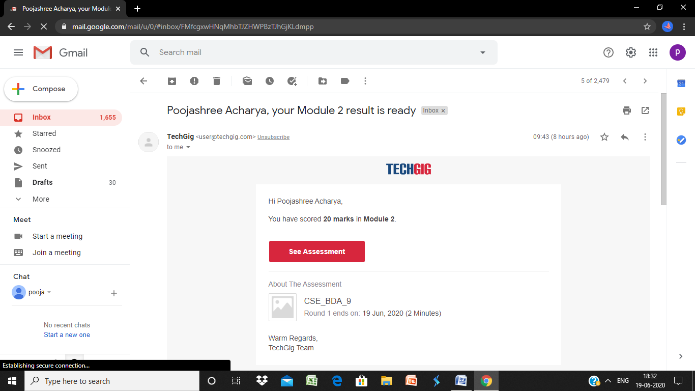

**Certification course**

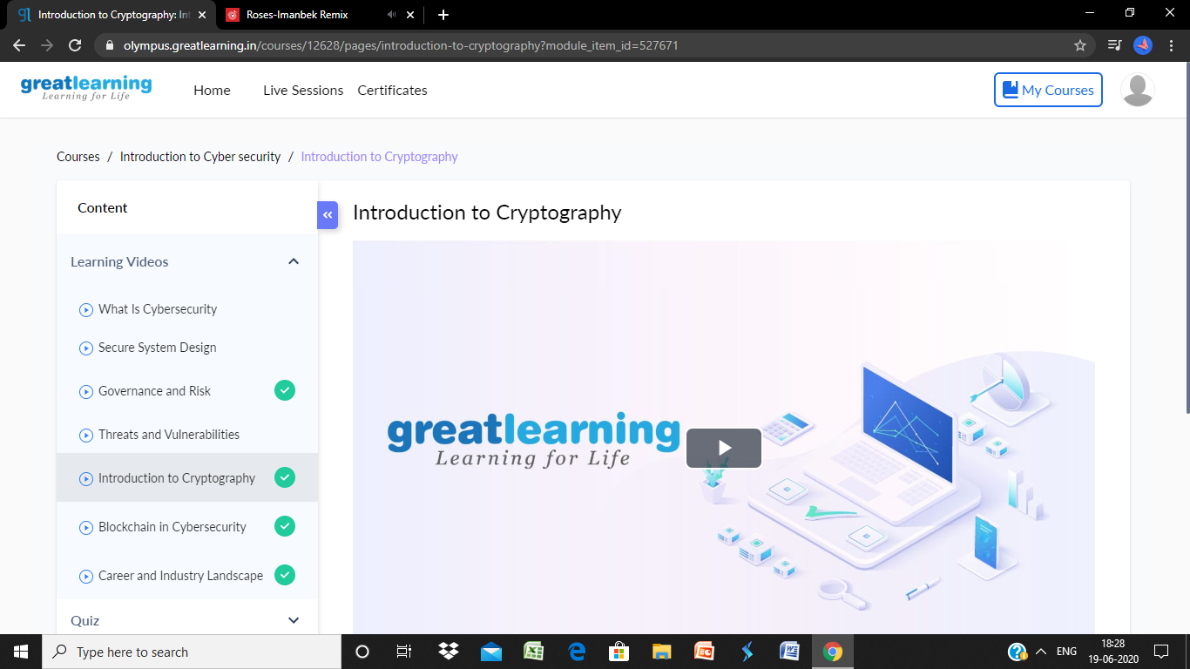

**Coding**

**Program 1**

#include <stdio.h>

int main()

{

//Initializing variables.

char str[100], str_no_spc[100];

int i=0, j=0 ;

//Accepting inputs.

printf("Enter the string:\n");

gets(str);

//Iterating each character of string.

while(str[i] != '\0')

{

if(str[i] != ' ')

{

str_no_spc[j++] = str[i];

}

i++;

}

str_no_spc[j] = '\0';

//Printing result.

printf("The string after removing all the spaces is:\n%s", str_no_spc);

return 0;

}